**TRAFFIC MANAGEMENT SYSTEM**

**PHASE 5: DEVELOPMENT PART 2**

**PROJECT OVERVIEW:**

This documentation presents the details of our IoT traffic management system project. Our objective is to efficiently control traffic at a 4-way junction using an Arduino Mega, ultrasonic sensors, and traffic light signals. The documentation outlines the specifics of our IoT traffic management system project, with the primary goal of implementing effective traffic control at a 4-way junction. This system leverages components such as the Arduino Mega, ultrasonic sensors, and traffic light signals. In addition, we're integrating a dynamic control system that responds to the density of traffic, ensuring efficient traffic flow and safety at the junction.

**COMPONENTS USED:**

List of components used in the project:

* Arduino Mega: The Arduino Mega microcontroller was chosen for its extensive I/O capabilities and enhanced processing power, ensuring comfortable and efficient implementation of the 4-way traffic management system. In addition, we're integrating a dynamic control system that responds to the density of traffic.
* Ultrasonic sensors
* LEDs for traffic lights
* Jumper wires
* Breadboard
* Power supply

**WIRING DIAGRAM:**

We provide a detailed wiring diagram to illustrate the connections between the Arduino Mega, ultrasonic sensors, and LEDs for the traffic lights. This diagram serves as a visual guide for setting up the project. In addition, we're integrating a dynamic control system that responds to the density of traffic (fig 2).

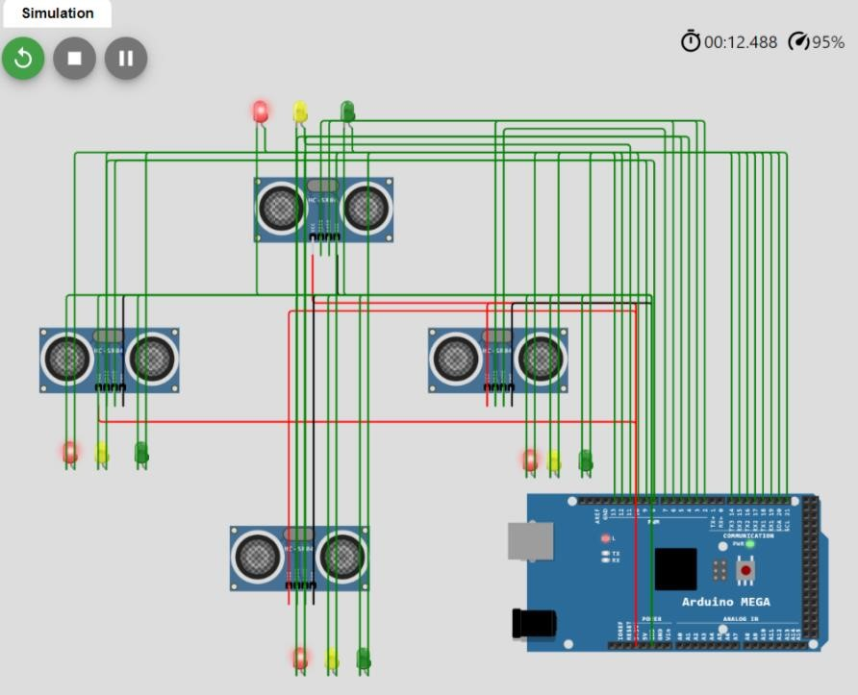

Fig1: traffic control at a 4-way junction

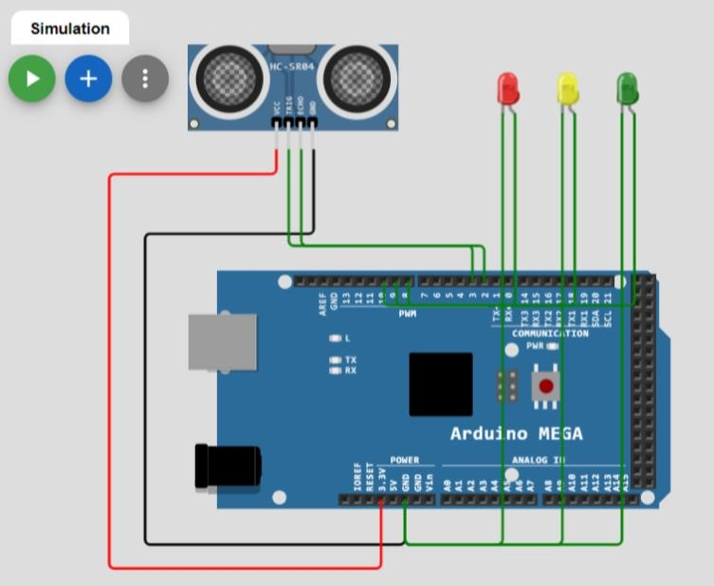

Fig2: Based on the density of traffic (Simulation)

**CODE EXPLANATION:**

Ultrasonic Sensor Measurement:

* Triggers the ultrasonic sensor to measure distance by sending a pulse.
* Measures the duration of the echo signal.
* Converts the duration into a distance in centimeters.

Traffic Density Calculation:

* Simulates vehicle density based on the measured distance.
* If the distance is less than 20 cm, it sets `trafficDensity` to 3 (high traffic density). - If the distance is between 20 cm and 50 cm, it sets `trafficDensity` to 2 (moderate traffic density).
* If the distance is greater than 50 cm, it sets `trafficDensity` to 1 (low traffic density).

Traffic Light Control:

* Adjusts the traffic light based on the calculated `trafficDensity`.
* If `trafficDensity` is 1, it switches to a green light.
* If `trafficDensity` is 2, it switches to a yellow light.
* If `trafficDensity` is 3, it switches to a red light.

Serial Output (for Debugging):

* Sends the current `trafficDensity` and distance to the serial monitor for debugging.

In summary, the code uses an ultrasonic sensor to measure the distance from an object and calculates a simulated traffic density based on that distance. It then adjusts the traffic light color (red, yellow, green) based on the simulated traffic density and provides debugging information through serial communication.

**PROJECT EXECUTION:**

To set up the project, follow the provided wiring diagram and upload the

Arduino code to the Arduino Mega. The code will start executing, and the system will actively control traffic at the junction.

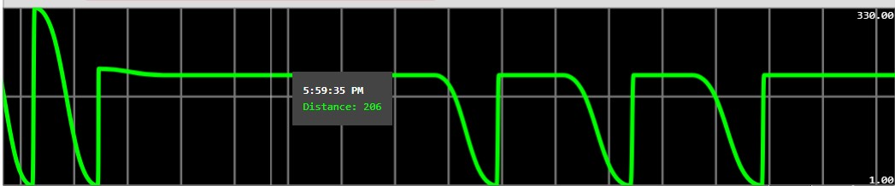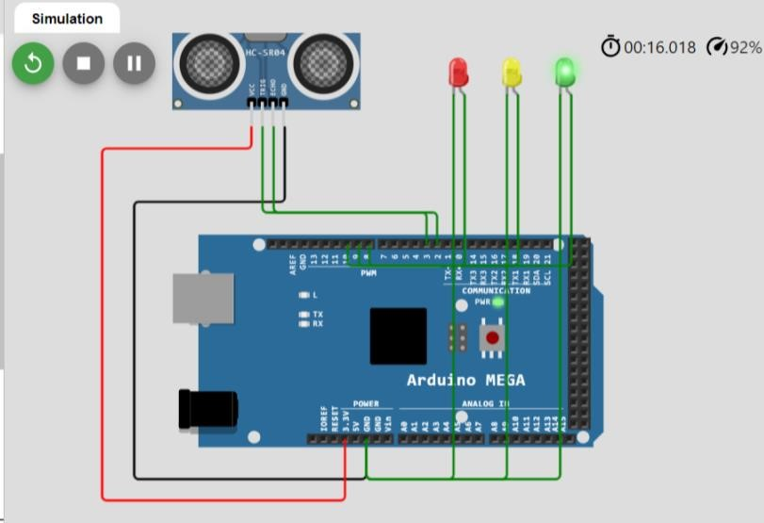

Simulation Code link:<https://wokwi.com/projects/380013999924449281>

**TESTING AND RESULTS**

We have assessed the project in multiple situation,emulating traffic condition at four intersection.the system adeptly react to the presence of vehicles ,streamlined traffic control and integrating a dynamic control system that responds to the density of traffic.

**CONCLUSION**

In conclusion, this IoT traffic management system project demonstrates the successful use of the Arduino Mega, ultrasonic sensors, and LEDs to control traffic at a 4-way junction. The project provides a practical solution for enhancing road safety and traffic efficiency.